TAMOXIFEN EFFECTS ON GENE EXPRESSION OF NEUROPROTECTIVE FACTORS
*Farangis Ghassemi¹, Fatemeh Khoshkam¹ and Aliyar Pirozi²
¹Department of Biology, Jahrom Branch, Islamic Azad University, Jahrom, Iran
²Cell and Molecular Research Center, Grash University of Medical Science, Shiraz, Iran
*Author for Correspondence
Please Include Suheadings shaded with Yellow colour in Your Article. Article such as Review article, Mathematical derivation don’t need to write MATERIALS AND METHODS

ABSTRACT
Astrocytes are the most glial cells in central nervous system those secrete protective factors. Tamoxifen is a non steroid drug and an antagonist of the estrogen receptor and was used in breast cancer treatment. In the present study the possible effects of tamoxifen on the morphology of astrocytes were investigated in vitro. After separating the cortex and tissue trituration of two rat embryo (wistar) were cultured in Dulbecco's Modified Eagle. Tamoxifen (8, 12 and 16) μmol/L was added to the cultured astrocytes for 72 hours. The cells were purified by trypsinization, determined and evaluated by immunocytochemistry technique. Astrocytes' morphologic changes were studied by invert electron microscope and gene expression of neuroprotective factors (BDNF, TGFβ1، TGFβ2) was determined. The Expression of the above-mentioned factors was confirmed by using RC-PCR technique and qualified the rate of them by PCR Real-time. The micrographs were prepared by immunofluorescence and data analyzed by statistical SPSS (18) soft ware. The results showed that treated cells were much higher amounts of TGFβ1 and TGFβ2 in comparison with the control cells. However, significant difference was not observed in the β actin expression (P< .001). As a result, tamoxiphine increased expression of neuroprotective activity of astrocytes. Also, it can help to regenerate the injured neural cells.
References must be cited as Author’s Surname/Last Name, with year within the brackets. Number or Numeric Superscript i.e., ¹ are not allowed.

Keywords: Astrocytes, Cortex, Neuroprotective Factors

INTRODUCTION
The glial cells (neuroglia) supports the neuaral cells and are useful for nutrition, activity and they have a role in the regulation of repair of neurons after injury in the central nervous system (Allen and Barres, 2005). The glial cell except Schwann divided to three types as oligodendrocyte, microglial and macroglial. Astrocytes are characteristic star-shaped the most abundant type of macroglial cell in the cortex¹ (Seth and Koul, 2008) [PLEASE REPLACE ALL NUMERIC VALUES/NUMBERS (IF WRITTEN) WITH AUTHORS SURNAME AND YEAR]. They have numerous projections for anchor neurons to their blood supply (Koehler et al., 2009).
They also have aqua porin (AQP) that makes them permeable to ions and various molecules as nucleotides, glucoside, peptide, cAMP, calcium, inositol and amino acids. They perform biochemical support of endothelial cells that form the blood–brain barrier, maintenance of extracellular ion balance, and a role in the repair and scarring process of the brain and spinal cord injuries (Volterra and Steinhäuser, 2004; Allen and Barres, 2005).
Recent studies have shown that astrocytes play an important function in the regulation of neural stem cells. They are able to activate the stem cells to transform into other neurons (Horner and Palmer, 2003). In brain injuries, these cells become active and will change morphologically (Aschner et al., 2002).
One of the most important functions of astrocytes is to secrete neuroprotective factors which are effective in neural survivals and regenerations of neurons. These factors are TGFβ (Transforming growth factor), BDNF (Brain-derived neurotrophic factor), Interleukin-10 and NGF or nerve growth factor (Dwivedi, 2009; Yan et al., 2009). Tamoxifen is an antagonist of the estrogen receptor in breast tissue via its active metabolite, hydroxytamoxifen. In other tissues such as the endometrium, it behaves as an agonist, and thus may be characterized as a mixed agonist/antagonist (Krishnan et al., 2003). So it is a useful drug for breast cancer treatment and ovulation. As it has antagonistic effects on hypothalamus and pituitary gland, it can pass the blood-brain barrier (Patterson et al., 1981). TGFβ which is isoform of TGF (Transforming growth factor) is in brain. Its isoform have two kinds of receptors (TβR-I TβR-II). TGF isoforms are active microglia. These factors are important in treatment of neural cells (Ronaldson et al., 2009). GFAP increase in neural damages as Alexander disease (Brenne et al., 2001). Other investigates have showed that BDNF and vascular endothelial growth factor (VEGF) contribute to neurovascular after stroke, and these responses involve both recovering endothelium and reactive astrocytes (Xiu et al., 2009). The effect of tamoxifen was studied in different organs previously (Ruffy, 2006; Wakade et al., 2008). In this study, the effects of it on expression of neuroprotective factors (BDNF, TGFβ₁ ،TGFβ₂₎ which were secrated by astrocyte, was determined by PCR.

MATERIALS AND METHODS THIS SUBHEADING IS NOT REQUIRED IN ARTICLE WITH MATHEMATICAL DERIVATIONS AND REVIEW ARTICLE
To do the research, the first step was culture astrocytes. For this purpose, all the devices and the laminar flow hood were sterilized in 160˚_{c}, the skin of two rat emberio (wistar) was disinfected and its head was cut. Then the skull was dissected from neck to frontal. After separating the cortex without any membrane, it was cleaned with Hank's buffered saline solution (HBSS), then was cultured in DMEM medium (Dulbecco's Modified Eagle) which include FBs 10%. Obtain cell were separated by trituration and transferred to DMEM. These cell after polilifratin and transferred. These cells were purified with trypsinization after one week and transferred to other flask. The isolated astrocytes were stained with triphan blue and counted with Neubauer slide. In the second step, the expression of GFAP (Glial fibrillary acidic protein) which is special marker for astrosyte by immunocytochemistry was investigated. To study this step, the cells cultured on the cover slips and was done as follow: The astrosytes were washed with PBS, fixed in paraformaldehyde 4% (15 minutes), cleaning with PBST (PBS+Tween), incubation in PBST 10% (was prepared from serum goat) in the room temperature for 45 minutes, Incubation these cells with antibody (GFAP) in 37˚_{c} for 60 minutes menthes, washing with PBST and studied by fleurscene microscope. In third step of experiment, the cultivated astrocytes were treated with (8, 12, and 16) μmol/L of tamoxifen for 72 hours. After treatment period, the cells separated by tripsin and RNA were extracted.
CDNA synthesis as follow:

Table 1: Program of cDNA synthesis
dNTP | dH2O | Buffer (10x) | MgCl₂ | Taq plymerase | Primer –Reverse(R) | Primer-Forward(F) | cDNA
5 μl | 9 μl | 3 μl | 2 μl | 5 μl | 1 μl | 1 μl | 5 μl
70 ºC: 10', 42ºC: h2، 25ºC: 10' و 70ºC: 5'

RT-PCR was done in later step. Β-actin primer was known as control.

Table 2: Program of cDNA synthesis by RT-PCR
dNTP | dH2O | Buffer (10x) | MgCl₂ | Taq polymerase | Primer –Reverse(R) | Primer-Forward(F) | cDNA
2 μl | 9 μl | 3 μl | 1 μl | 5 μl | 1 μl | 1 μl | 5 μl
95ºC: 5', 60 ºC: 17', 72ºC: 1', 72 ºC: 1'
After doing PCR, the primer sequence was determined and genes expressions were confirmed by RT-PCR. Data were obtained (Pfaffl et al., 2003) and was calculated ratio by below formula:
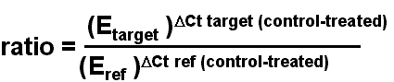
Threshold Cycle (CT), Efficiency (E)
The end f experiment, statistical soft ware (SPSS) and test ANOVA (P< .001) were used and data analyzed.

RESULTS AND DISCUSSION

Table 1: The gene expression of TGFβ₁ in tomxiphen treated cells
SE | Mean±SE | Ratio |  |  |  |  |  | Tamoxifen
.66662 | 3.7033 | 1.75 | 5.98 | 2.19 | 4.22 | 4.92 | 3.16 | 8 μmol/L
.44856 | 6.6417 | 5.64 | 6.81 | 7.01 | 8.54 | 6.27 | 5.58 | 12 μmol/L
.25041 | 8.1617 | 8.03 | 7.9 | 8.6 | 9.05 | 8.13 | 7.26 | 16 μmol/L

Table 2: The gene expression of TGFβ₂ in tomxiphen treated cells
SE | Mean±SE | Ratio |  |  | Tamoxifen
.49168 | 4.4433 | 4.94 | 4.93 | 3.46 | 8 μmol/L
.75056 | 7.1167 | 5.82 | 7.11 | 8.42 | μmol/L 12
.44916 | 8.7333 | 7.87 | 9.38 | 8.95 | 16 μmol/L

Table 3: The gene expression of BDNF in tomxiphen treated cells
SE | Mean±SE | Ratio |  |  | Tamoxifen
.18148 | 2.9100 | 3.19 | 2.97 | 2.57 | 8 μmol/L
.28109 | 4.3733 | 3.96 | 4.25 | 4.91 | μmol/L 12
.25500 | 7.4450 | 8.82 | 7.70 | 7.19 | 16 μmol/L

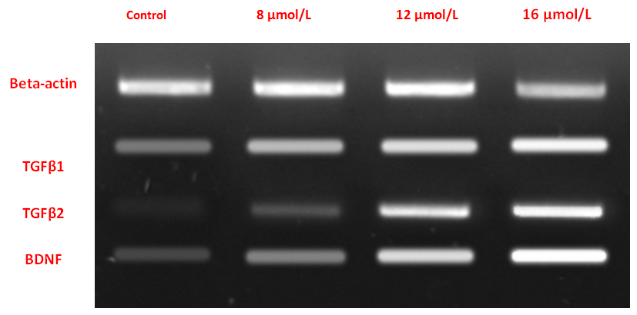

Figure 1: The effect of tamoxifen on expression of neuroprtective factors in Rat embryo
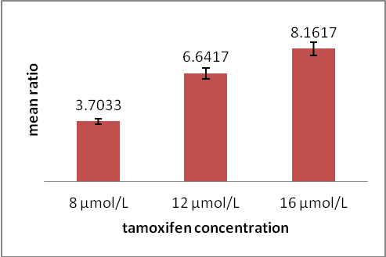 | 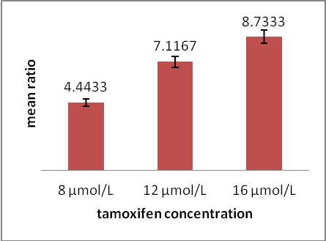
Figure 2: The expression of neuroprotective factor (TGFβ₁) | Figure 3: The expression of neuroprotective factor(TGFβ₂)

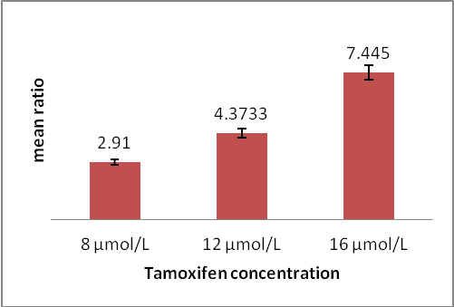

Figure 4: The expression of Brain-derived neurotrophic factor (BDNF)

Results
This study showed that tamoxifen increased the expression of BDNF, TGFβ_{1’} TGFβ₂ which were secreted by astrocytes and this effect was dose- dependent. Also was shown that this drug didn’t affect the expression of β actin. The obtained results of real time PCR were demonstrated in tables (1-3) and Figures (1-4).
Discussion
If injuries happen in the central nervous system, physiologic mechanisms will be activated and one can refer to the glial cells (Yan et al., 2009). Astrocytes are the most effective to control of neural cell and its survival by secretion of the factors such as TGFβ1, TGFβ2, GDNF, and NT3 (Seth and Koul, 2008; Siegel et al., 2000).
The researchers isolated astrocyte from either enzymatically or mechanical methods. Mechanical method depending on size of cell and based on different adhesion properties, divided to two ways (Lim and Miller, 1989). In this study, astrocytes isolated by mechanical method, because these cells have high adhesion property and prepared high purely. Also in this method the membrane of cells don't damage.
Although astrocytes were isolated from different part of CNS (Barres, 2008), but numerous of them were located within white matter as cortex. On the other hand, the neuroprotective factors which were important in proliferation, differentiation and protection of neurons are secreted by astrocytes (Broer et al., 2001; Ronaldson et al., 2009).
According to the obtained results in this study, tamoxifine increased expression of these protective factors and effect of it, depended to dose of drug consume (Mikulec et al., 2000). The previous investigates showed that the some compound such as 17β-Estradiol (E2) and selective estrogen receptor modulators (SERMs), such as tamoxifen, mediate numerous effects in the brain, including neurosecretion, neuroprotection, and the induction of synaptic plasticity (Naoko and Shinichi, 2003; Ronaldson et al., 2009).
Previous reports showed that tamoxifen is neuroprotective against apoptotic cell death via ER-dependent mechanism in Rat (Zhang et al., 2007). The astrocytes have receptors with kinase property those active signaingl pathways (Wang et al., 2006). They activate PI3K/Akt pathway, PI₃ kinase, phospholipase C and proto-oncogene that become an oncogene due to mutations or increased expression (Hanada et al., 2004; Dhandapani et al., 2005). The WNT pathway is the most of them and it encode a large family of secreted protein growth factors such as TGF-Betas (Transforming Growth Factor-Betas), FGFs (Fibroblast Growth Factors), Hedgehog and Notch proteins that have been identified in animals from Hydra to Human. Wnt signaling pathway was actived via inhibiting of enzyme GSK-3β (Glycogen synthase kinase 3 beta) that it is a key molecule (Koh et al., 2004).
Whereas seems in present research, tamoxifen effects on cortical astrocytes via PI3K/Akt pathway and inhibiting GSK-3β enzyme that due to increasing of neural protective cells (TGFβ₁, TGFβ₂). Since it is the most important endocellular signaling pathway in cell division, cell migration, cell survival, determination and its disorder cause neurodegenerative diseases (Lu et al., 2005; Liu et al., 2003). The inhibitor induced IGF expression and activation Wnt pathway that increase neuron survival (Koh et al., 2004). The GSK3β is important in growth factor secretion and these factors are effective on signaling pathway. Moreover TGFβ and BDNF receptors are in astrocytes. So we can say that tamoxifen increase the above factors via inhibit GSK3β.
Conclusion
Cortical astrocytes could provide a mechanism of neuroprotection, and that tamoxiphen stimulation of TGF-β expression. Tamoxifen increase expression of TGFβ and BDNF that probably act via direct impact or increased activity of Wnt signaling pathway by inhibiting the GSK3β. Therefore, this pathway can be activated by using agonists as tmoxifen and increased neural expression of protective factors. Since these factors can play a tremendous impact on neural survival and recovery of damaged CNS.

ACKNWLEDGEMENT
We are grateful to Islamic Azad University, Jahrom branch authorities, for their useful collaboration.

REFERENCES [INCOMPLETE REFERENCES WILL NOT BE ACCEPTED-ARTICLE CAN GET DELAYED FOR NOT FOLLOWING THE JOURNAL’S PATTERN. PLEASE REMOVE THE REFERENCES WHICH ARE INCOMPLETE AND IRRELEVANT]

Allen NJ and Barres BA (2005). Signaling between Glia and Neurons: Focus on Synaptic Plasticity, Current Opinion in Neurobiology 15 542-548.
Aschner M, Sonnewald U and Tan KH (2002). Astrocyte modulation of neurotoxic injury. Brain Pathology 2(4) 475-81. THIS IS HOW JOURNAL’S REFERENCE IS WRITTEN
Barres BA (2008). The Mystery and Magic of Glia: A Perspective on Their Roles in Health and Disease, Neuron 60 430-440.
Borthakur SK (1997). Plants in the folkflore and folk life of the Karbis (Mikirs) of Assam. In: Contribution to Indian ethnobotany, Vol 1, 2nd edn, edited by Jain SK (Scientific Publishers, Jodhpur) 169-178. THIS IS HOW BOOK REFERENCE IS WRITTEN
British Lawnmower Museum (No date) Lawnmowers of the Rich and Famous [Online] Southport, British Lawnmower Museum. Available: http://www.lawnmowerworld.co.uk/Rich.htm [Accessed 10 March 2004] THIS IS HOW ONLINE WEBSITE REFERENCE IS WRITTEN
Brenner M, Johnson AB, Boesphlug Tanguy O, Rodringuez D, Goldman JE and Messing A (2001). Mutations in GFAP, Encoding Glial Fibrillary Acidic Protein, are associated with Alexander disease. Nature 27(1) 117-120.
Broer S and Brookes N (2001). Transfer of glutamine between astrocytes and neurons. Journal of Neurochemistry 77 705-719.
Dhandapani KM, Marlene Wade F, Virendra B Mahesh and Darrell W Brann (2005). Astrocyte-derived transforming growth factor-beta mediates the neuroprotective effects of 17beta-estradiol: involvement of nonclassical genomic signaling pathways. Endocrinology Journal 146(6) 2749-2759.
Dwivedi Y (2009). Brain-derived neurotrophic factor: role in depression and suicide. Neuropsychiatric Disease and Treatment 5 433–49.
Hanani M (2005). Satellite Glial Cells in Sensory Ganglia: from Form to Function. Brain Research Reviews 48 457-476.
Hart K (1998) The place of the 1898 Cambridge Anthropological Expedition to the Torres Straits (CAETS) in the history of British social anthropology. Science as Culture. [Online] 11. Available: http://human-nature.com/science-as-culture/hart.html [Accessed 9 November 2003] THIS IS HOW ONLINE ARTICLE/TOPIC REFERENCE IS WRITTEN
Horner PJ and Palmer TD (2003). New roles foastrocytes: The nightlife of an astrocyte. La Vida Loca. Trend in Neuroscience 26(11) 597-603.
WRITE FULL TITLE OF THE ARTICLE
Koehler RC, Roman RJ and Harder DR (2009). Astrocytes and the regulation of cerebral blood flow. Trends in Neuroscience 32 160-169.
Koh SH, Noh MY and Kim SH (2008). Amyloid-beta-induced neurotoxicity is reduced by inhibition of glycogen synthase kinase-3. Brain Research 188 254-62.
Krishnan M Dhandapani and Darrell W (2003). Brann Neuroprotective Effects of Estrogen and Tamoxifen in Vitro Endocrine 21(1) 59–66.
Lim R and Miller JF (1989). Isolation of rat astrocytes. Alan R. Liss, Inc. New York 92-104.
Liu SJ (2003). Overactivation of glycogen synthase kinase-3 by inhibition of phosphoinositol-3 kinase and protein kinase C leads to hyperphosphorylation of tau and impairment of spatial memory. Journal of Neurochemistry 87(6) 1333-44.
Lu J, Wu Y, Sousa N and Almeida OFX (2005). SMAD pathway mediation of BDNF and TGFβ2 regulation of proliferation and dif ferentiation of hippocampal granule neurons. Development 132(14) 323-1- 3242.
WRITE FULL NAME OF JOURNAL IN PLACE OF ITS ABBREVIATED NAME. ALSO WRITE VOLUME AND ISSUE NUMBER AND PAGE NUMBERS
Mikulec AA, Hanasono MM, Lum J, Kadleck JM, Lum, J, Kadleck JM, Kita M and Koch RJ (2001). Effect of tamoxifen on transforming growth factor beta l production by keloid and fetal fibroblasts. Archives of Facial Plastic Surgery 3(2) 111-4.
Naoko K and Shinichi W (2003). 17-Estradiol Enhances the Production of Nerve Growth Factor in THP-1-Derived Macrophages or Peripheral Blood Monocyte-Derived Macrophages. Journal of Investigative Dermatology 121 771–780.
Patterson J (1981). Clinical aspects and development of antiestrogen therapy: a review of the endocrine effects of tamoxifen in animals and man. Journal of Endocrinology 89 67-75.
Pfaffl MW (2001). A new mathematical model for relative quantification in real-time RT-PCR. Nucleic Acids Research 29(9) 45.
Ronaldson PT, Demarco KM, Sanchez-Covarrubias L, Solinsky CM and Davis TP (2009). Transforming growth factor-beta signaling alters substrate permeability and tight junction protein expression at the blood-brain barrier during inflammatory pain. Journal of Cerebral Blood Flow & Metabolism.
Ruffy MB (2006). Effect of tamoxifen on normal human dermal fibroblast. Archives of Facial Plastic Surgery 8(5) 329-32.
Seth P and Koul N (2008). Astrocyte, The Star Avatar: Redefined. Journal of Biosciences 405-421.
Wakade C, Khan MM, De Sevilla LM, Zhang QG, Mahesh VB and Brann DW (2008). Tamoxifen neuroprotection in cerebral ischemia involves attenuation of kinase activation and superoxide production and potentiation of mitochondrial superoxide dismutase. Endocrinology 149 367– 379.
Wang Z, Li DD, Liang YY, Wang DS and Cai NS (2002). Activation of Astrocytes by Advanced Glycation End Products: Cytokines Induction and Nitric Oxide Release. Acta Pharmacologica Sinica 23 974-98.
Xiu MH, Hui L, Dang YF, De Hou T, Zhang CX, Zheng YL, Chen DC, Kosten TR and Zhang XY (2009). Decreased serum BDNF levels in chronic institutionalized schizophrenia on long-term treatment with typical and atypical antipsychotics. Biological Psychiatry Journal 33(8) 1508–12.

